Coursework Report

Ryan Dignan

[40316221@napier.ac.uk](mailto:40316221@napier.ac.uk)

Edinburgh Napier University – Web Tech SET08101

**1 Introduction**

I have been assigned to create a website that can convert text into an encoded form. The types of encoding have been left to my discretion and I have chosen Caesars Cipher and Binary as my two. My webpage has 3 pages, a home page and a page for each of my Ciphers.

**2 Software Design**

**2.1 Page design**

Home page:

Gif

Description

**Title**

Button 2

Button 1

Caesar Cipher:

Button 2

Button 1

Key Dropdown

Textbox

Gif

Description

**Title**

Binary Conversion:

Textbox2

Gif

Textbox1

Button 2

Button 1

**Title**

Description

**2.2 Relationship Diagram:**

Caesar Cipher

Binary Conversion

Home

**3 Implementation**

My site works as outlined in the specification. All links to other pages work and both the encryption and decryption ends of both my cipher pages work. The encrypt and decrypt functions for the Caesar Cipher work based from a key which chooses the offset for the letters. The Binary encrypt and decrypt functions work from separate textboxes and the corresponding buttons for each function.

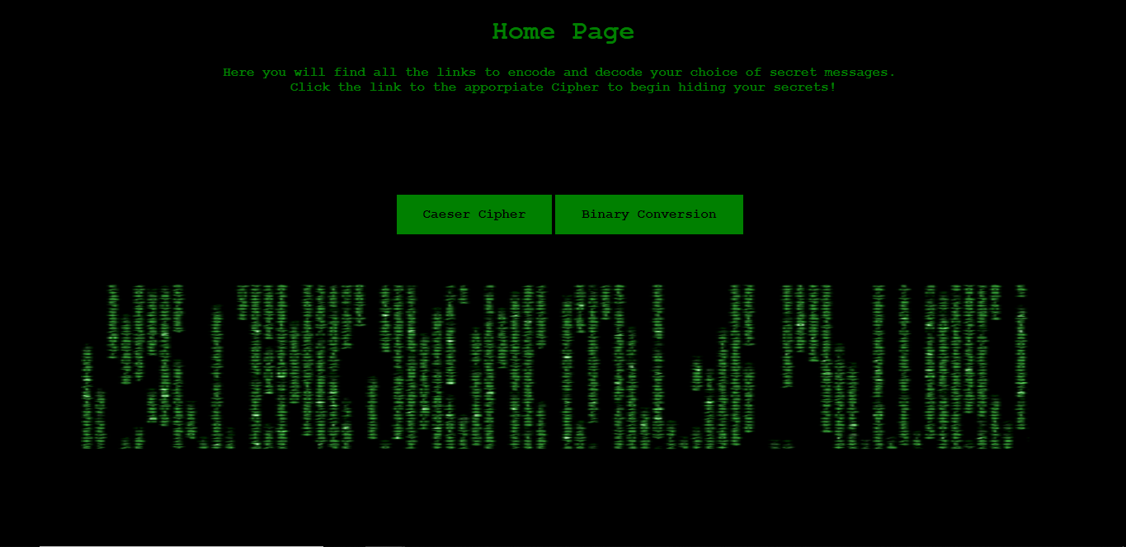Homepage:

Caesar Cipher:

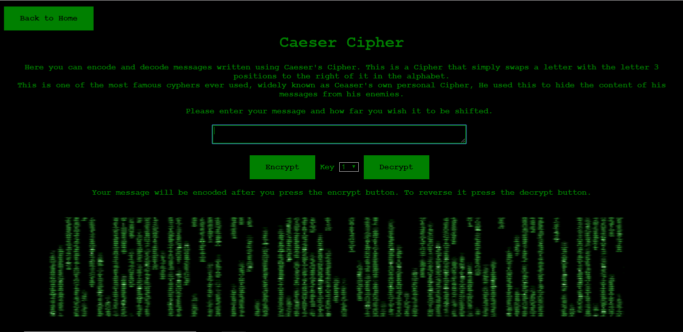

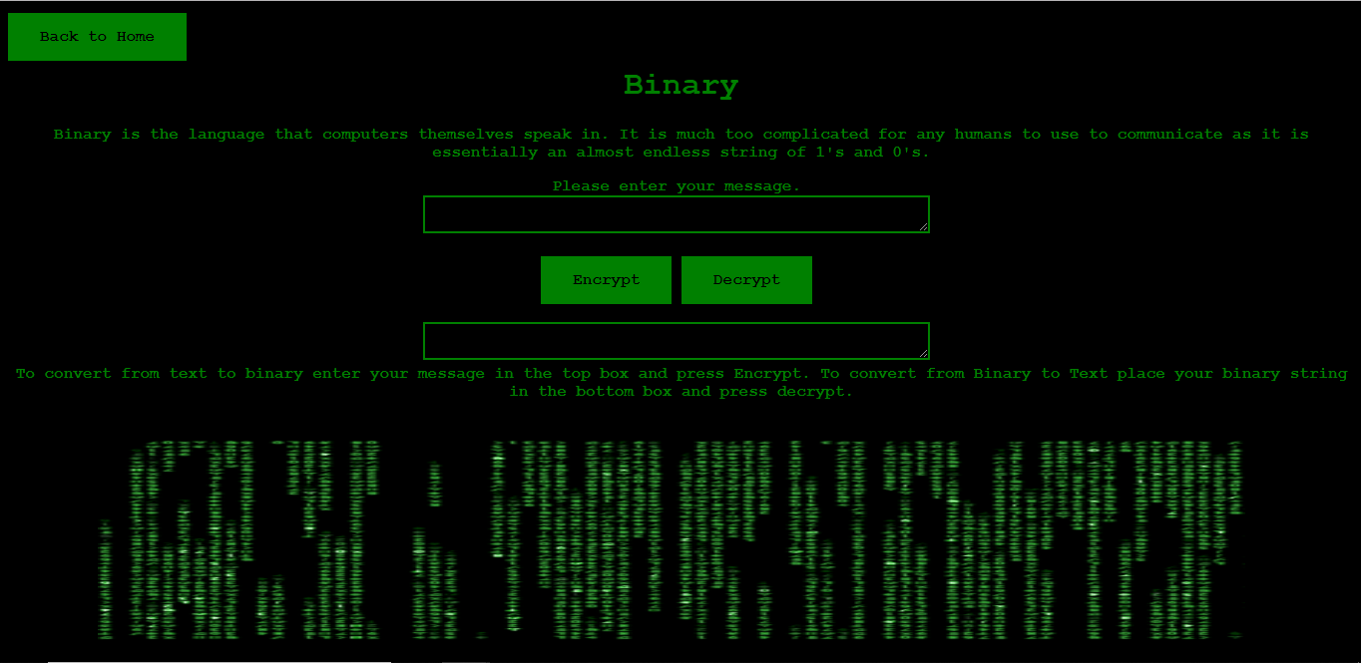Binary Conversion:

**4 Critical Evaluation**

My webpage fills out all the requirements that were set out in the original specification but unfortunately not much else. It has two pages for two ciphers whose functions perform as intended. Some improvements that could be made include:

* Adding more ciphers
* An “About” page
* More graphics or varied graphics to make the design appear more appealing

**5 Personal Evaluation**

I am happy with this finished product but do also think there are some improvements to be made. The most challenging part of this assignment was getting the JavaScript Functions to work, especially the conversion from binary to text. It was a rewarding experience finding solutions to problems I had been grappling with for hours and gave me a great sense of accomplishment when I finally finished. I feel overall I have performed well but I do need to improve upon my time management skills as I fear they are slightly lacking as I left some things to do later than I should have.